THE CHECKERED EYE PROJECT

409 Peirson Avenue, Port Elgin, ON, N0H 2C1

(519) 389-4956 [info@checkeredeye.com](mailto:info@checkeredeye.com)

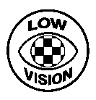

Dear Eye Care Specialist,

The Checkered Eye Project (CEP) was created to increase awareness of partial blindness, a.k.a. low vision, and the Checkered Eye, a symbol which may be worn by people to indicate they have this condition. The new symbol is already in use in many parts of Canada, the U.S., and New Zealand.

Since vision care practitioners are an important source of information regarding coping strategies for people with various levels of visual impairment, we hope that you will make information about the checkered eye available to your staff, clients, and their caregivers.

To participate in this awareness process, you may simply refer people to the CEP website. You may also choose to print or request the pamphlets or posters from the site. There are also other awareness “boosters” (such as stickers and magnets) which are available upon request. We hope you will also print checkered eye information in any newsletters or other publications you distribute.

Sincerely,

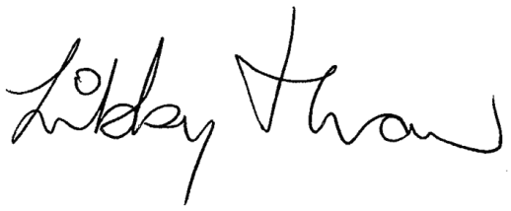

Libby Thaw

checkeredeye.com